**Shahzaib Riaz**

**Roll No: 12391**

**Data Structure and Algorithm**

**Lab Task 5**

Q1: Implement a basic queue using an array in Python. Include methods for enqueue, dequeue, checking if the queue is empty, and finding the size of the queue.

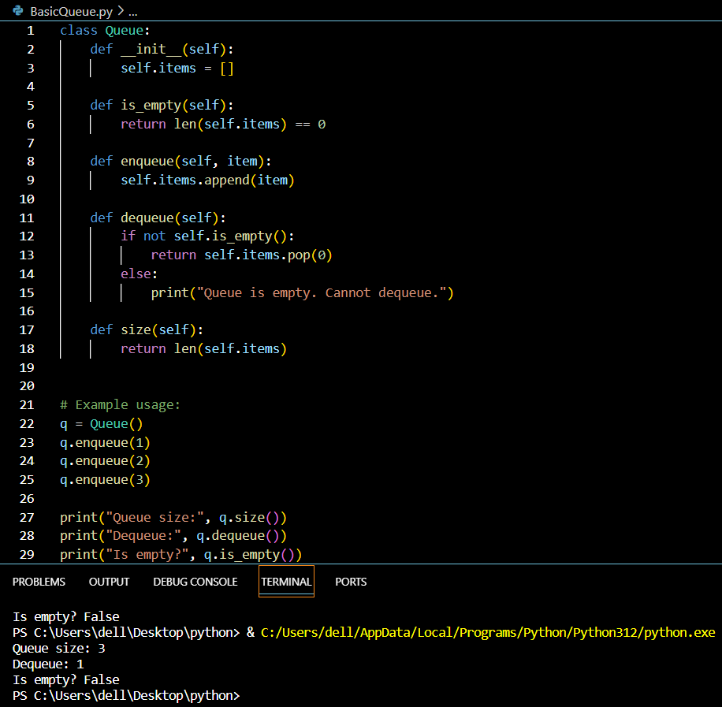

Q2: Implement a circular queue in Python. Include methods for enqueue, dequeue, checking if the queue is empty, checking if the queue is full, and finding the size of the queue. give me a proper program.

